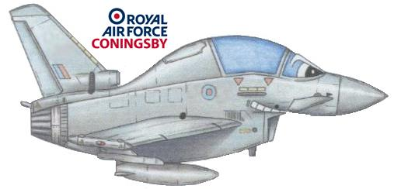
RAF Coningsby Community Centre
Tattershall
Lincolnshire
LN4 4QZ

Tel: 01526 347211
Email:clintoncommunitycentre@yahoo.com
BOOKING FORM
Contact Name: | Contact Number: |  | Email:
Facilities required: ( Please circle each facility you wish to use during the booking)
Large Main Hall |  | Small Hall |  | Meeting Room
Do you require access to tables and chairs? (please circle)
Yes | No

Date of Use: (Please specify day/s)

Names for key list: 1.
2.
Time requested (please ensure you allow sufficient time to set up and clear down)
Morning | Afternoon | Evening

Payment for use of the Community Centre is £20 per session, plus a £20 refundable deposit. I accept the deposit will be used towards the payment of cleaning and repair costs if the premises are left damaged or untidy.

Once your requested date and time has been confirmed by a member of the Community Centre committee then payment is to be made via BACS (for the session only) to Bank – RBS, Sort Code – 16-19-26, Account Number - 10818605. The reference needs to be 203160 followed by your date of booking for example; 203160 22 Jan 18. The refundable deposit should be paid by cheque, cheques are to be made payable to Service Funds RAF Coningsby. These should be sent to the Hive Office (for attn. of Cpl Kim Smith).

I hereby agree to use the building in accordance with the conditions of use, a copy of which is attached to this booking form.

A receipt, along with building instructions, will be sent via email once confirmation of payment has been made.

Signature of User | Date
On behalf of RAF Coningsby Community Centre | Date

For administrative use only

Deposit received: YES/NO | Receipt Number:
Payment received: YES/NO | Deposit Returned: YES/NO Date:
Confirmation Sent YES/NO Date:

